 VINOD SIR’S GROUP TUTION

MATHS-I-PRACTICE PAPER

1. 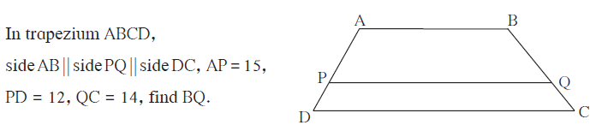
2. Areas of two similar triangles are 225 sq.cm. 81 sq.cm. If a side of the smaller triangle is 12 cm, then find corresponding side of the bigger triangle.

3. Find the diagonal of a rectangle whose length is 35 cm and breadth is 12 cm.

4.
5. 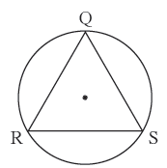 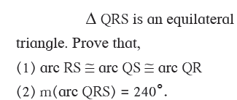

6.

7. 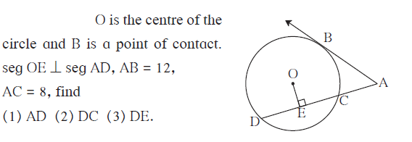

8. 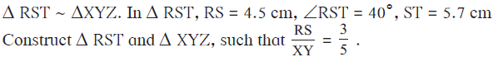

9. Draw a circle with radius 3.4 cm. Draw a chord MN of length 5.7 cm in it. Construct tangents at point M and N to the circle.
10. Find x if distance between points L(x, 7) and M(1, 15) is 10.

11. Find the ratio in which point P(k, 7) divides the segment joining A(8, 9) and B(1, 2). Also find k .

12. Show that A (-4, -7),B (-1, 2), C (8, 5) and D (5, -4) are the vertices of a parallelogram.

13. Two buildings are facing each other on a road of width 12 metre. From the top of the first building, which is 10 metre high, the angle of elevation of the top of the second is found to be 60°. What is the height of the second building?

14. 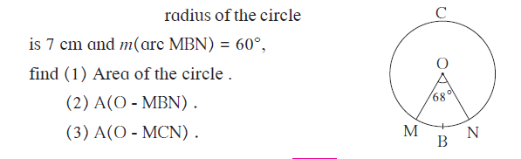

15. The area of a minor sector of a circle is 3.85 cm2 and the measure of its central angle is 36°. Find the radius of the circle.

